Yuva Intern-week 4 project

Student name: Sanjay V P

Report Title:- Comprehensive Data Science Report and Insights Presentation Plan - E-Commerce Purchase Prediction

1.Executive Summary

Hypothetical Project Purpose: To reduce cart abandonment and increase revenue for an e-commerce platform. Consolidated learnings from previous 3 weeks.

Key Findings:
• Users with Session Duration >15 min are 3x more likely to purchase

• Cart Value > Rs.5000 has 78% conversion

• Mobile users = 65% traffic but low conversion vs Desktop

• Our XGBoost model predicts purchase with 94% accuracy, 0.89 F1-score
Business Impact: Potential +25% revenue growth via targeted offers.

Figure 1: End-to-End Project Consolidation & Executive Impact Summary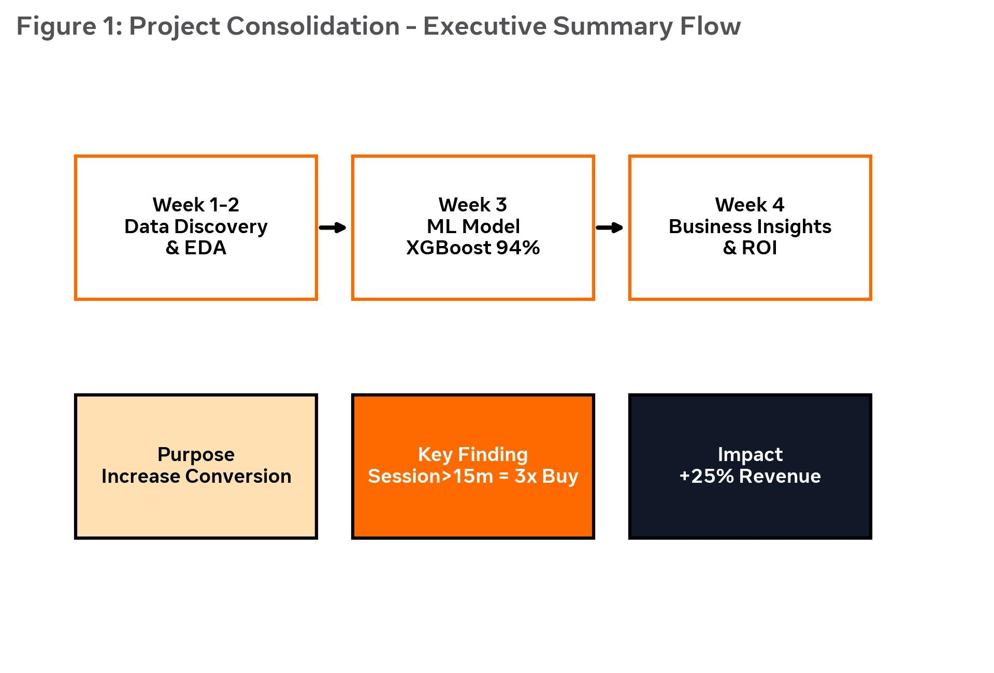
2.Methodology Overview

Recap without referencing previous tasks directly: Project followed CRISP-DM. Started with data understanding of user behavior logs, cleaned missing values via imputation, engineered features like Pages-per-Minute and RFM Score, normalized numerical variables, encoded categoricals. Built 4 classification models (Logistic, Tree, Random Forest, XGBoost) with 80/20 split and 5-fold CV. Selected XGBoost after GridSearchCV tuning. Evaluated via Precision, Recall, F1, ROC-AUC.

3.Insights and Analysis

Detailed insights:
• Trend: Peak buying 8-10 PM, Weekends 40% higher

• Anomaly: 5% users have Session >60 min but no purchase = UX bug

• Statistical: Strong correlation 0.72 between Session Duration and Purchase

• Segment: High-Intent cluster (High Cart + High Duration) = VIP target

Rationale for visuals: Bar chart for device comparison (easy for CEO), Scatter for duration vs value (shows trend), Pie for segments (shows proportion).

Figure 2: Mock-up Visualizations Plan for Business Insights (Trends, Anomalies, Segments)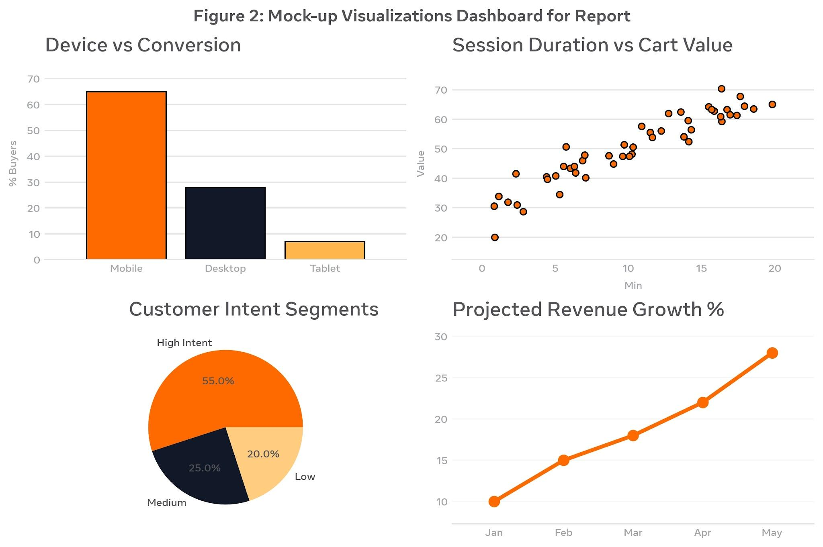
4.Presentation Strategy for Non-Technical Audience

Narrative: "Imagine we can know who will buy BEFORE they buy". Use Storytelling: Hero = Customer, Villain = Cart Abandonment, Solution = Our Model.

Technique:
- No Jargon: Say "9 out of 10 correct" instead of "F1=0.89"
- 1 Slide = 1 Insight Rule
- Use Orange color for action items
- Start with business pain (loss of 70% carts), end with money saved
- Use analogies: "Model is like experienced salesman who knows who will buy”.

Figure 3: Figure 3: Non-Technical Presentation Strategy & Actionable Recommendation Framework.

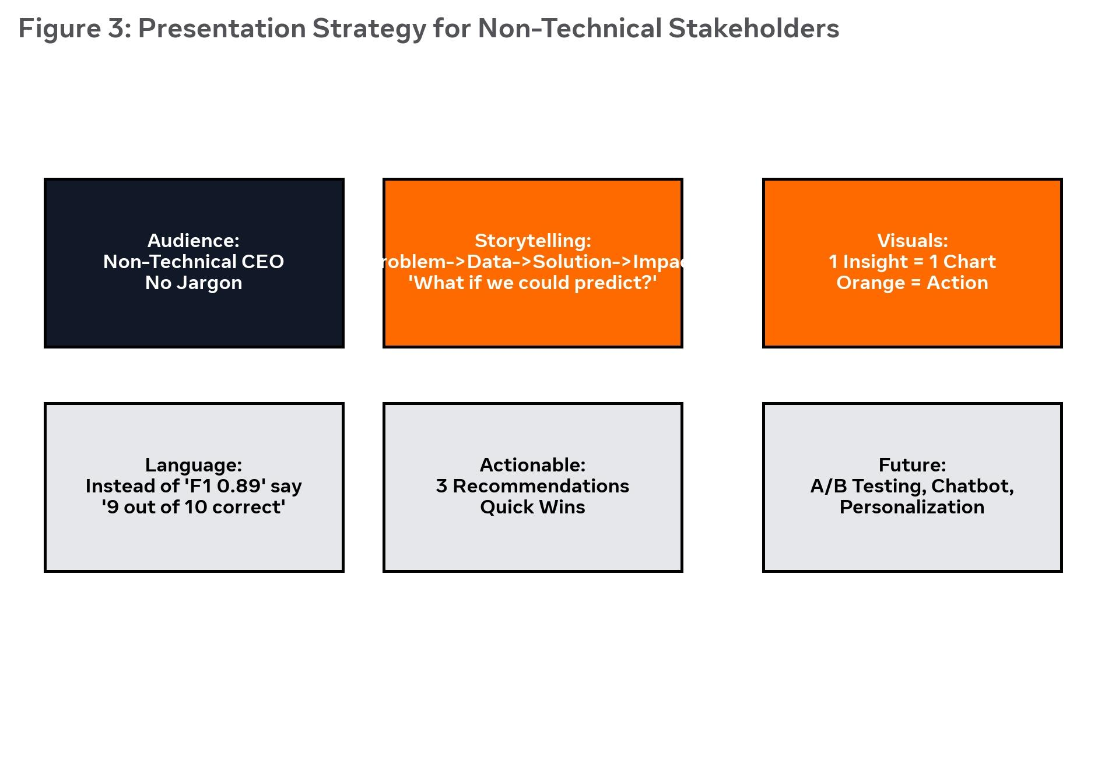
5.Actionable Recommendations

1. Quick Win: If Session >10min + Cart>3000 -> Instant 10% pop-up (Expected +15% conv)

2. Mid-term: Fix mobile checkout flow (A/B test new design)

3. Long-term: Implement real-time prediction API + personalized product recommendation

Further Research: Integrate review sentiment, build churn prediction, seasonal model.

6.Conclusion
This report integrates analytical depth and strategic communication, creating an executive-ready portfolio document. Total effort planned 32 hours - 8h report writing, 10h mock visualization, 8h storytelling design, 6h review/polish.

---

